附件6
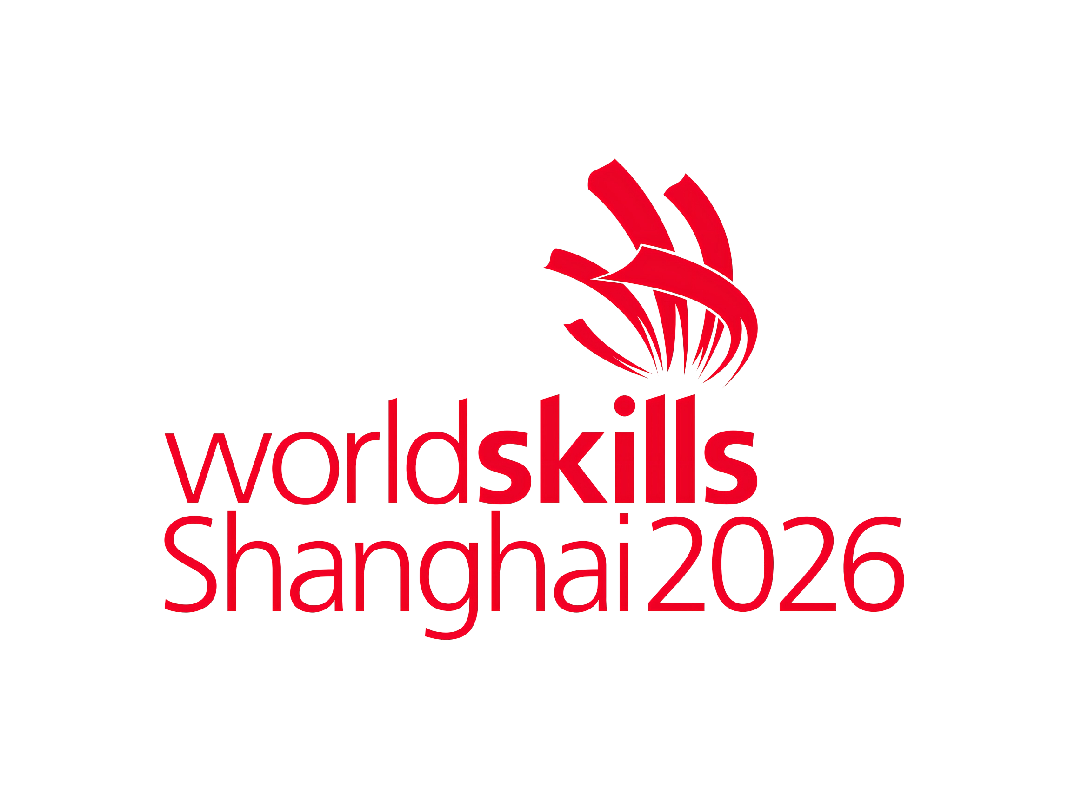
2026年第48届世界技能大赛自用物资安全卫生责任自负声明
Safety and health Liability Statement of Self-use Goods for The Worldskills Shanghai 2026

利益相关方名称Name of stakeholder:
航班号Flight Number:
本方保证附表所列物资符合安全卫生标准，如本方在使用期间出现任何安全卫生问题，本方将自行承担一切相关责任。
We hereby declare that the goods on the list meet the relevant safety and health standards. In case of any safety and health problems arising from the use of the goods listed, we will assume all related responsibilities.
签署人（授权签字官姓名、职务）Signature(Rank,name of Authorised Signing Officer):__________________
日期Date: (YYYY/MM/DD)
（正本：主管海关留存；副本1：进境地海关留存；副本2：所有人或代理人留存。）

