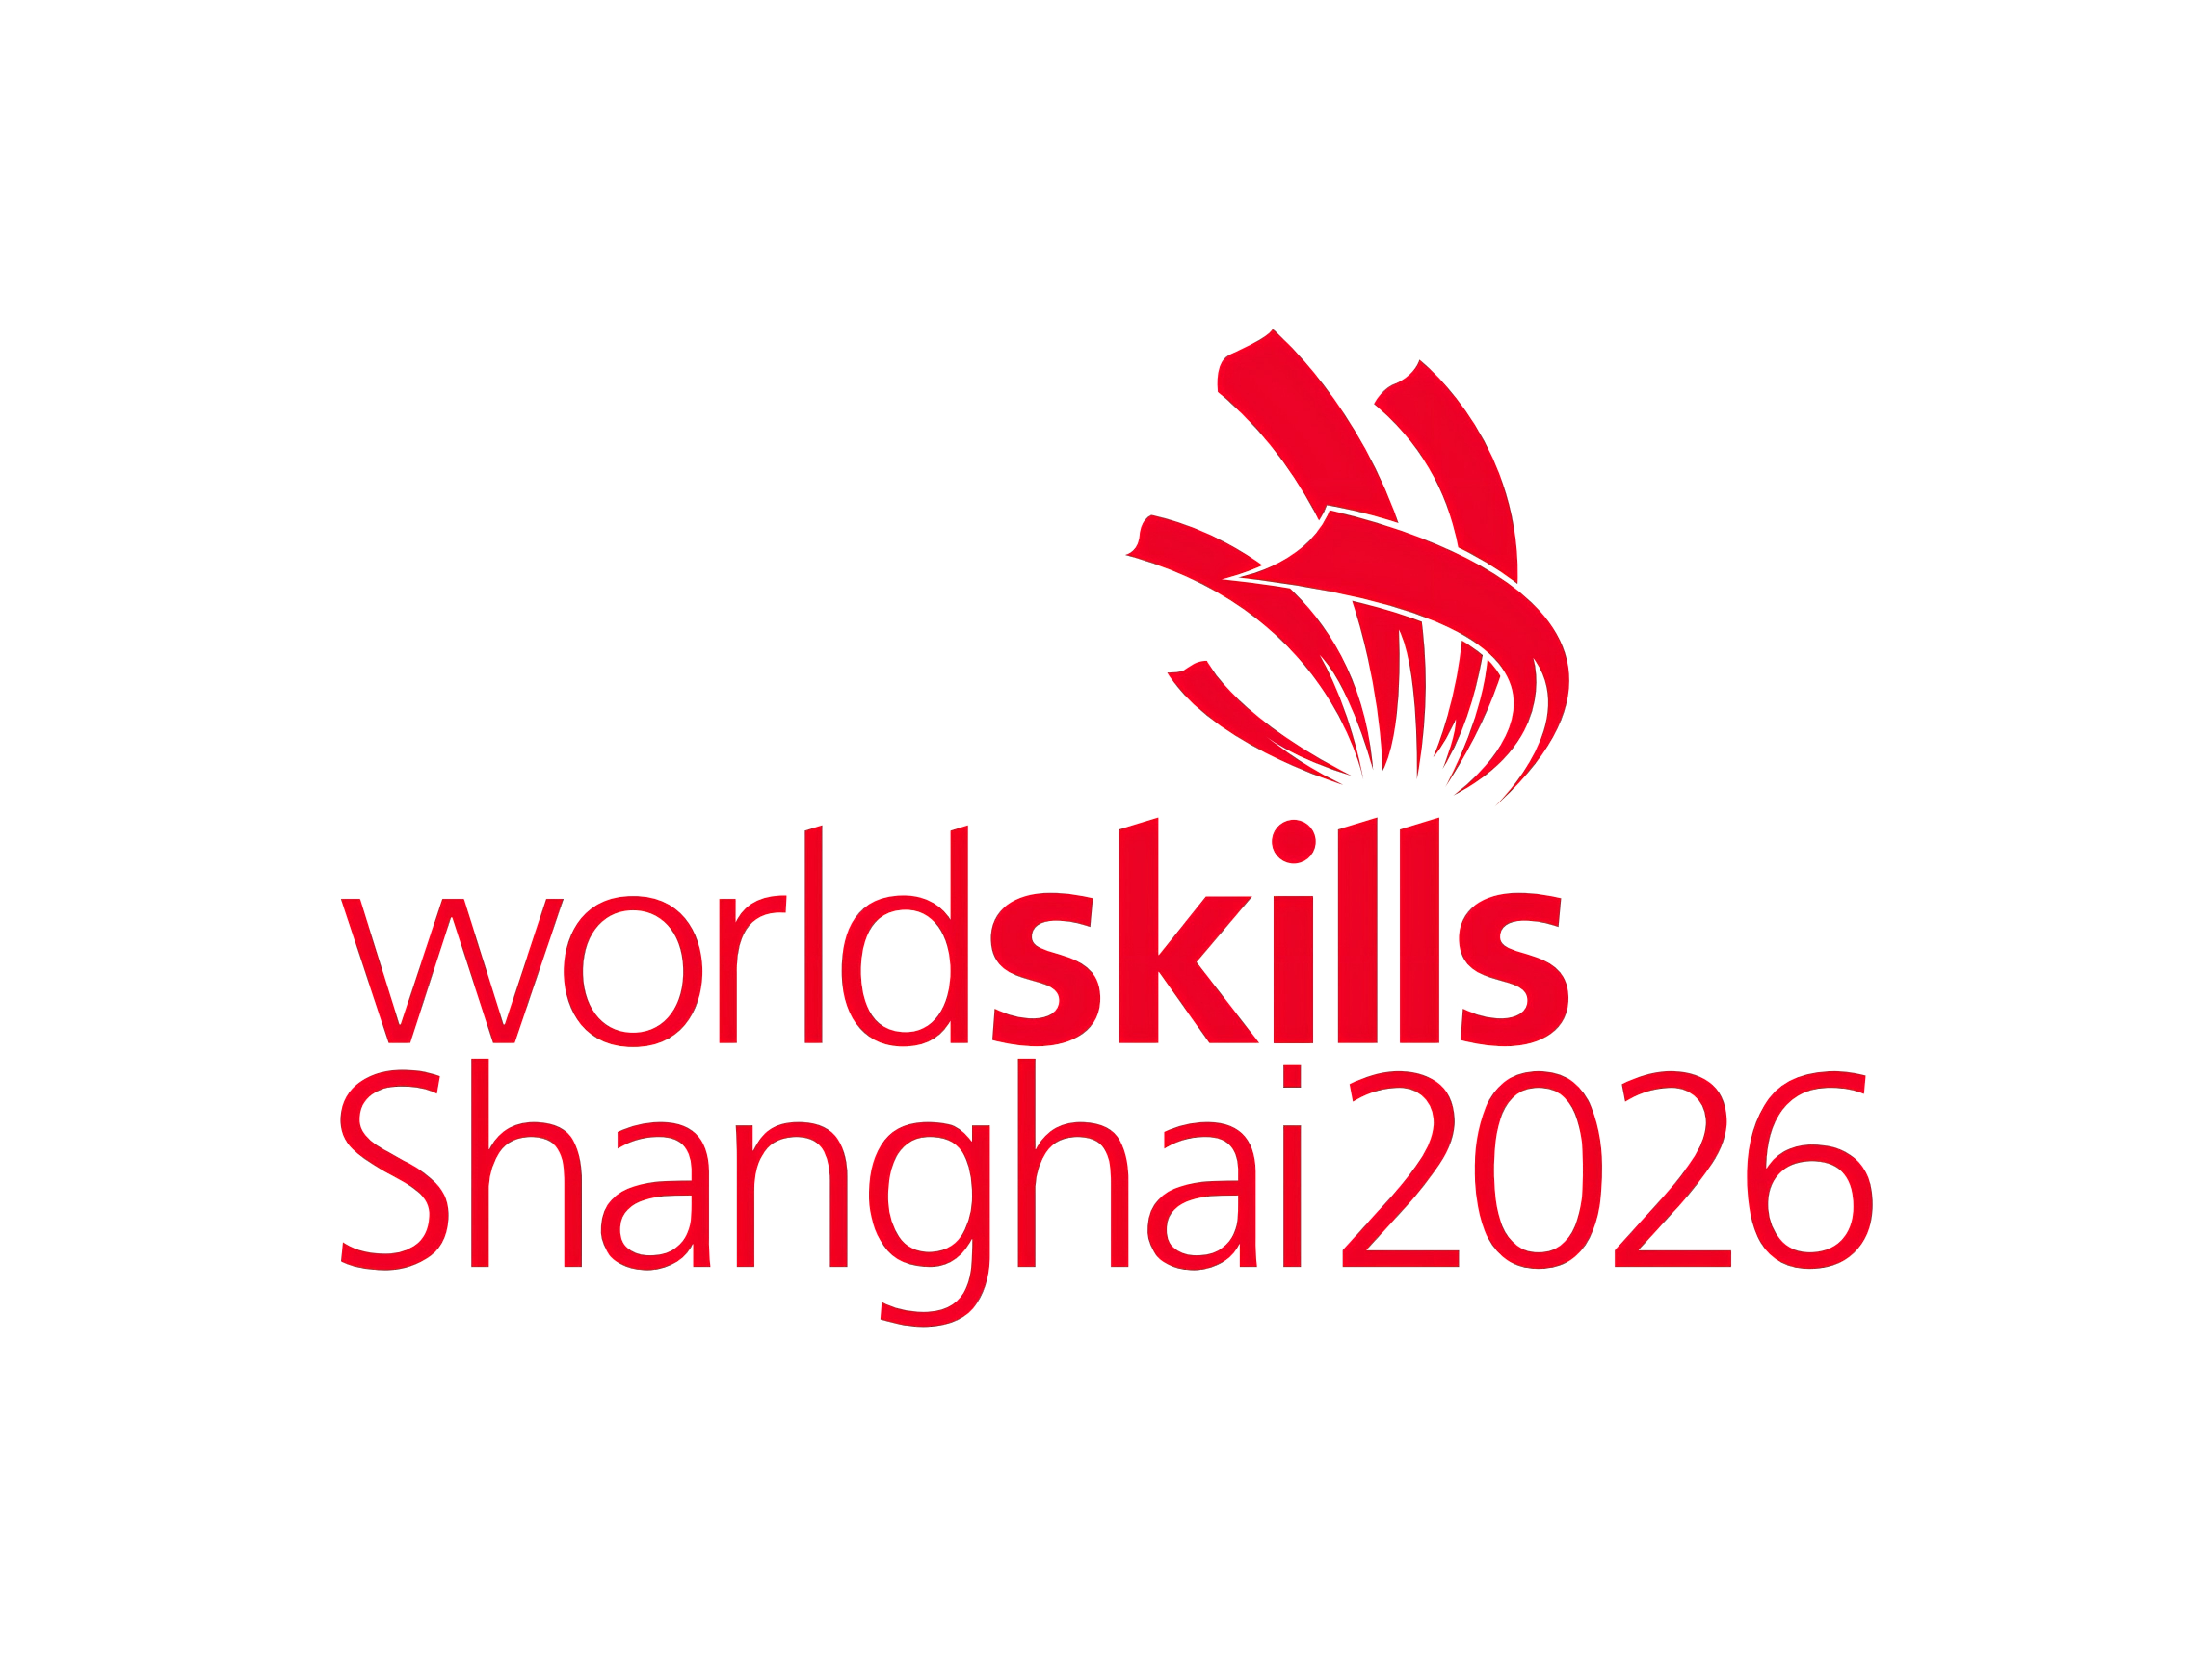
附件5
2026年第48届世界技能大赛进境物资自用证明
Declaration of Self-use of Imported Goods for The Worldskills Shanghai 2026

利益相关方名称（Name of stakeholder）:
航班号Flight Number:
本方保证附表所列物资全部为自用，保证不在本方之外使用。如有剩余，保证退运或在上海海关的监督下销毁。如有违反，本方将承担一切相关责任。
We hereby declare that the goods on the list are imported for the purpose of self-use and not for other purposes. Goods unused will be re-exported or destroyed under the supervision of Shanghai Customs District People's Republic of China. In case of any violation, we will assume all related responsibilities.

签署人（授权签字官姓名、职务）Signature(Rank,name of Authorised Signing Officer):
日期Date: (YYYY/MM/DD)
（正本：主管海关留存；副本1：进境地海关留存；副本2：所有人或代理人留存。）

